Peter Truong van Phuc,SJ.
Jesuit Mission in Suai
Suailoro Village
Suai Sub- District
Timor Lorosae ( East Timor).

Suailoro village, June 26th, 2006.

Dear Mr. Mike,

President of Outreach Asia, Inc.

In the last letter on May 29th, 2006, I had intention to ask your helping us to construct a new safe water system for the poor people in Suailoro Village, Suai sub-distict, East Timor. And I were very happy when to know that your generosity accepted to support. But almost last month, I can’t find out technician to drill the well. Until now, local people have not professional ability in making a drilling well equipped with a pump. So in sadness, I want to change my intention. However, I continue to hope that: in the future people in Suailoro village will have a safe water system as my intention.

I want to send to you some information and pictures about situation of inhabitants at Suailoro village, where I serve as missionary.

Suailoro is an agricultural village belong to Suai sub-district, in the south of Timor Lorosae ( East Timor), at 8 hours driving distance from capital Dili and at 30 minutes driving distance from Indonesia – East Timor border. Population of this village more or less 2000. most of the villagers just came back from refugee camp ( in year 2002 - the war for the independence of Timor Lorosae from Indonesian) and they are very poor. ( See P.1: A part of Suailoro village; P.2: House of Suailoro villager; P.3: A toy of children – A ball make from coconut leaf).
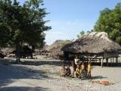
Picture1: A part of Suailoro village

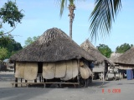
Picture 2: House of Suailoro villager

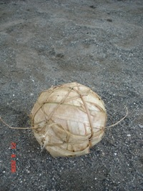
Picture3: A toy of children – A ball make from coconut leaf

This village has more 1100 children in school age (according to the statistic data of population of year 2005). Although there are 2 public primary school for this village, many poor children at school age can’t to go to school because they have no enough financial ability to pay school fees. These poor children have to work hard in order to help their families. ( See P.4: Catch fish for helping family).
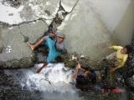
Picture4: Catch fish for helping family

The villagers in Suailoro have wide farms but most of these farms are left fallow because of alang grass ( thatch grass). In the war time, through 3 years ( 1999 – 2002) no cultivation, thatch grass grow in all the farms, now the villager can’t cultivate any crops. ( See P.5: The Farm is left fallow because of thatch grass).

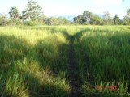
Picture5: The Farm is left fallow because of thatch grass

With rudimentary methods and simple farming tools, the villagers cultivate some crops: cassava, maize, green peas, groundnut among thatch grass. ( See P.6: Cassava among thatch grass; P.7: Villagers clear of weeds by rudimentary methods; P.8: Sow green peas).
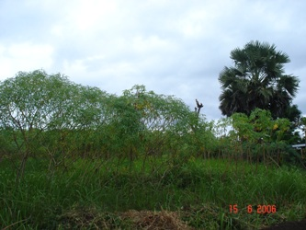
Picture6: Cassava among thatch grass

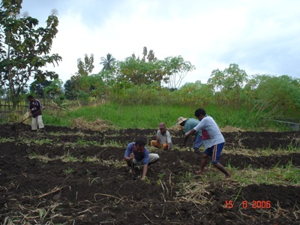
Picture7: Villagers clear of weeds by rudimentary methods
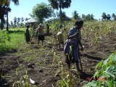
Picture8: Sow green peas.

With the poor agricultural situation as now, Suailoro’s inhabitants have no enough staple food for themselves. Many their children are in malnutrition ( See P.9: A newborn baby 3 weeks age in malnutrition).

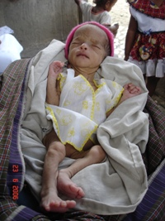
Picture9: A newborn baby 3 weeks age in malnutrition

Our Jesuits follow villagers came back from refugee camps since 2002 ( in group working in JRS: Jesuit Refugee Service). Until now, we live and work with villagers in the farms. We try to help them rehabilitate the economy by many programme: Classes for the poor children, training course on agricultural technology, Nursery garden supply nurseling for the farmers... ( See P.10: Classe for the poor children in Suailoro). However, every year we needs the great support form benefactors and benerfactresses.

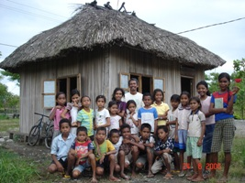
P.10a: Classe for the poor children in Suailoro ( outside)

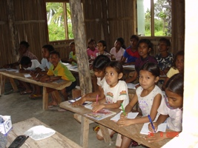
P.10b: Classe for the poor children in Suailoro ( inside)

In present, with our poor conditions, we want to express heartfelf asking your supporting to our missions in serving the poor Suailoro’s villagers. If possible, you can help us to buy 1 tractor in order to help farmer plough and clears of weeds ( clear of thatch grass) on fallow farms. With tractor, we hope that we can help the people rehabilitate the economy in height efficiency.
While waiting your consideration, we want to express heartfelt thanks to you, to benefactors, benefactresses all in advance.

Sincerely,
Peter Truong Van Phuc, SJ.

